**Construct Binary Tree from Preorder and Inorder Traversal**

<https://leetcode.com/problems/construct-binary-tree-from-preorder-and-inorder-traversal/>

Given two integer arrays preorder and inorder where preorder is the preorder traversal of a binary tree and inorder is the inorder traversal of the same tree, construct and return *the binary tree*.

**Example 1:**

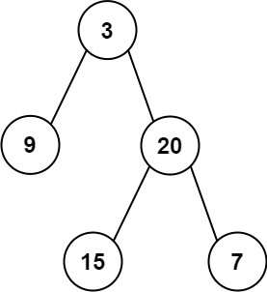

**Input:** preorder = [3,9,20,15,7], inorder = [9,3,15,20,7]

**Output:** [3,9,20,null,null,15,7]

**Example 2:**

**Input:** preorder = [-1], inorder = [-1]

**Output:** [-1]

**Constraints:**

* 1 <= preorder.length <= 3000
* inorder.length == preorder.length
* -3000 <= preorder[i], inorder[i] <= 3000
* preorder and inorder consist of **unique** values.
* Each value of inorder also appears in preorder.
* preorder is **guaranteed** to be the preorder traversal of the tree.
* inorder is **guaranteed** to be the inorder traversal of the tree.